TikTok Stable Diffusion Comment to Image App

1. Follow the 2nd way🡪 the Manual way to install stable diffusion from stable-diffusion/docs/installation/INSTALL_WINDOWS.md

Follow till step 8.

1. Install MySql and make a table exactly similar to this one below:

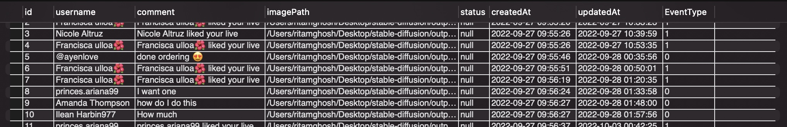

1. Put the Launcher.py, python1.py in the scripts folder of the stablediffusion folder. And replace the dream.py given there with the dream.py that has been provided by me.
2. Put proper credentials there to connect to the mysql server and in the Launcher.py put the username of a tiktok account that is live at the moment as a value for unique_id like this:

unique_id=’asmr_mikiii’

1. If you are in a region like India where TikTok has been banned you need to install and activate a vpn before running the code.
2. To run the code:

1.Put the whole stable-diffusion folder on your desktop

2. Open command prompt and write:

cd desktop

cd stable-diffusion

conda activate ldm

python scripts/Launcher.py

1. As pre-requisites you must have a python interpreter and vpn installed and configured in your system already.